Libraries imported successfully!

Dataset loaded successfully!
label message
0 ham Go until jurong point, crazy.. Available only ...
1 ham Ok lar... Joking wif u oni...
2 spam Free entry in 2 a wkly comp to win FA Cup fina...
3 ham U dun say so early hor... U c already then say...
4 ham Nah I don't think he goes to usf, he lives aro...

Dataset shape: (5572, 2)

Class distribution:
label
ham 4825
spam 747
Name: count, dtype: int64

Number of messages in each class:
label
ham 4825
spam 747
Name: count, dtype: int64

Class percentages:
label
ham 86.59
spam 13.41
Name: proportion, dtype: float64
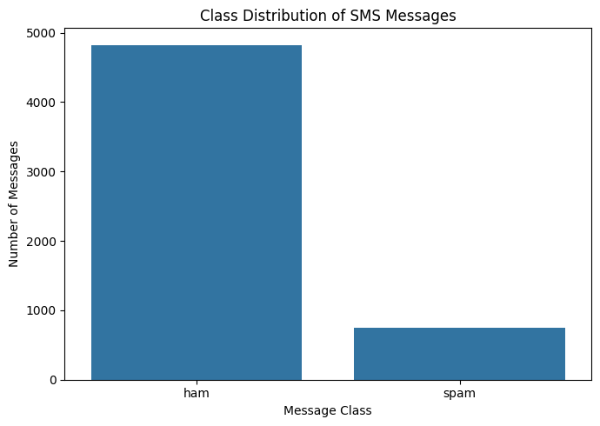

Preprocessing completed!
Total messages: 5169

Label distribution:
target
0 4516
1 653
Name: count, dtype: int64

Training samples: 4135
Testing samples: 1034

Training class distribution:
target
0 0.874
1 0.126
Name: proportion, dtype: float64

Testing class distribution:
target
0 0.873
1 0.127
Name: proportion, dtype: float64

TF-IDF conversion completed!
Training feature shape: (4135, 10000)
Testing feature shape: (1034, 10000)

Naive Bayes training completed!
Logistic Regression training completed!
Linear SVM training completed!

All models trained successfully!

MODEL EVALUATION RESULTS

Model Accuracy Precision Recall F1-Score Balanced Accuracy MCC PR-AUC (Average Precision)
Naive Bayes 0.9652 1.0000 0.7252 0.8407 0.8626 0.8351 0.9505
Logistic Regression 0.9555 0.9775 0.6641 0.7909 0.8310 0.7850 0.9624
Linear SVM 0.9787 0.9580 0.8702 0.9120 0.9323 0.9013 0.9765

=======================================================
MODEL: Naive Bayes
=======================================================
precision recall f1-score support

Ham 0.9617 1.0000 0.9805 903
Spam 1.0000 0.7252 0.8407 131

accuracy 0.9652 1034
macro avg 0.9808 0.8626 0.9106 1034
weighted avg 0.9665 0.9652 0.9628 1034

=======================================================
MODEL: Logistic Regression
=======================================================
precision recall f1-score support

Ham 0.9534 0.9978 0.9751 903
Spam 0.9775 0.6641 0.7909 131

accuracy 0.9555 1034
macro avg 0.9655 0.8310 0.8830 1034
weighted avg 0.9565 0.9555 0.9518 1034

=======================================================
MODEL: Linear SVM
=======================================================
precision recall f1-score support

Ham 0.9814 0.9945 0.9879 903
Spam 0.9580 0.8702 0.9120 131

accuracy 0.9787 1034
macro avg 0.9697 0.9323 0.9499 1034
weighted avg 0.9785 0.9787 0.9783 1034

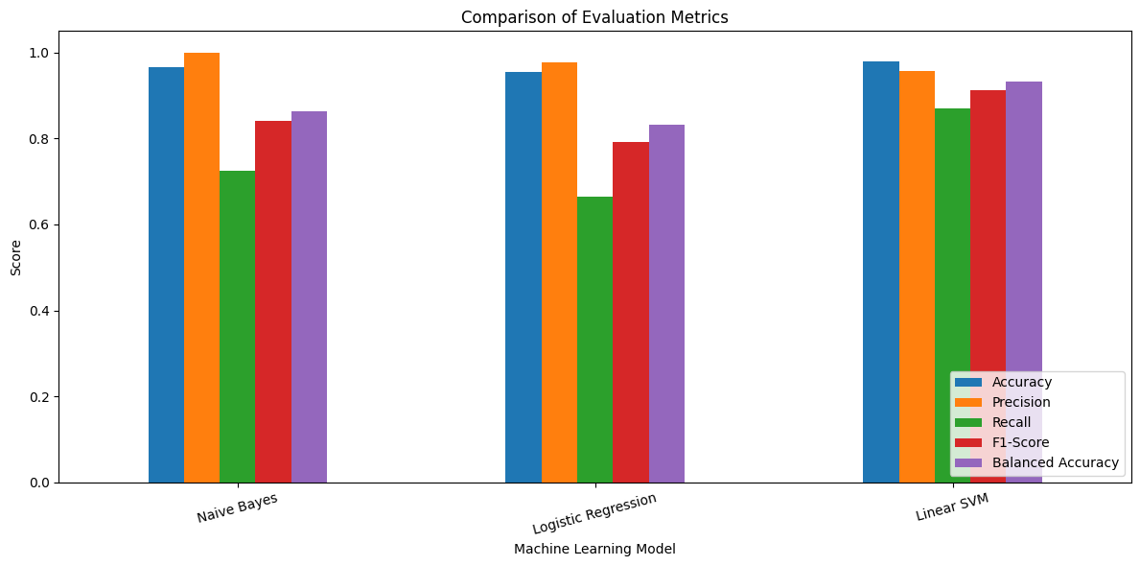
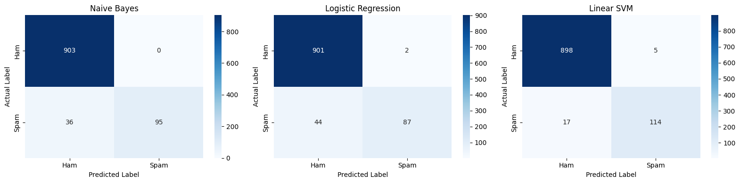

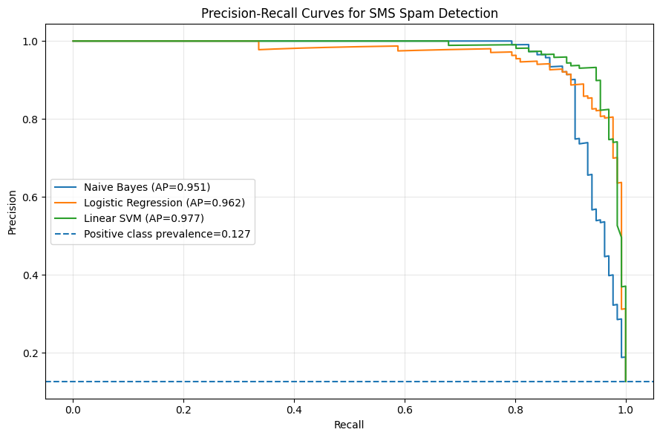

BEST MODEL FOR EACH METRIC

Accuracy: Linear SVM (Score = 0.9787)
Precision: Naive Bayes (Score = 1.0000)
Recall: Linear SVM (Score = 0.8702)
F1-Score: Linear SVM (Score = 0.9120)
Balanced Accuracy: Linear SVM (Score = 0.9323)
MCC: Linear SVM (Score = 0.9013)
PR-AUC (Average Precision): Linear SVM (Score = 0.9765)

